Dear Sir/Madam,

On behalf of the Investment Agency of the Republic of Moldova, it is my greatest pleasure to invite you to attend the 7th edition of Moldova Business Week to be held on November 19-20.

MBW-2020 will take place in digital format, ensuring a safe online space for participation, reconceptualized to enhance the awareness of the Republic of Moldova globally as a hidden gem for investment, offering an experience that creates connections.

By joining this unique platform to explore investment, trade and economic opportunities of the Republic of Moldova you’ll enjoy a new level of engagement and interactivity between participants, keeping networking at the core of the event experience.

This year’s program will focus on harmonious combination between the global knowledge’ sharing regarding megatrends and FDI, while local companies from strategic economic sectors: ICT, BPO, R&D and Electronic Manufacturing, Infrastructure, Fashion and Agrifood, - will spotlight their investment profiles for the perfect international matching.

The Government panel will give an insight into investment-related proactive policies aimed at supporting business climate, leading the Republic of Moldova towards a digital economy. Top challenges, innovations and technologies adjusted to a new economic reality will be addressed by inspirational leaders, insightful experts and visionary entrepreneurs.
Made in Moldova brands will showcase their testimonials on how the international recognition can be built in a country with untapped potential for growth.
We anticipate your acceptance to this invitation and extend it to concerned business associations, investment funds, national authorities in charge of investment and trade, your business community.
You are invited to join and connect to more than 1000 business partners, leading Republic of Moldova towards a Digital, Sustainable and Resilient Economy.
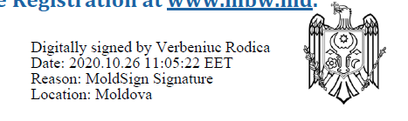
* The participation is ensured by the online Registration at www.mbw.md
Yours sincerely,
Rodica VERBENIUC
General Director of the Moldovan Investment Agency

