Shanghai International Arbitration Summit

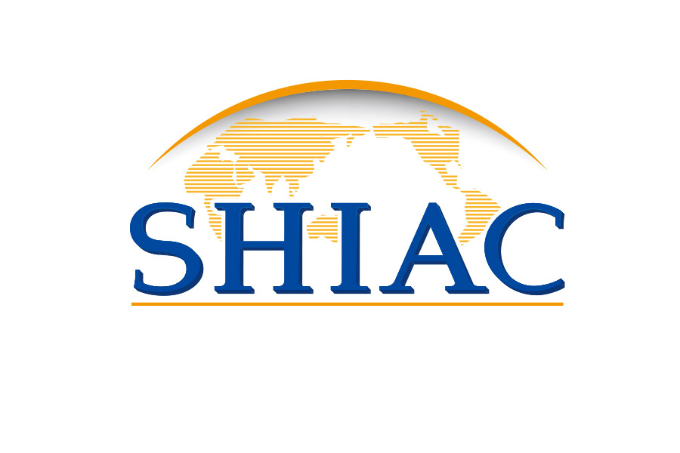
The Shanghai International Arbitration Summit (hereinafter referred to as “Summit”) will be held at 2:00 pm on November 8, 2019 in D1 Exhibition Hall of National Exhibition and Convention Center (Shanghai), China. The theme of the Summit is Opening-up, cooperation, and win-win.
The Summit is a side event for the 2nd China International Import Expo, co-hosted by Shanghai Municipal Bureau of Justice and Council for the Promotion of International Trade Shanghai, organized by Shanghai International Economic and Trade Arbitration Commission (Shanghai International Arbitration Center), and supported by Shanghai Arbitration Association.
Program of the Summit (Primary Version)
13:30-14:00 | Registration
14:00-14:30 | Welcome remarks
14:30-15:30 | 1st Session: International Arbitration Opening-up and Business Environment Improvement
15:30-15:50 | Tea break
15:50-16:50 | 2nd Session: China-Africa Route of International Arbitration Cooperation
16:50-17:50 | 3rd Session: Win-Win Collaboration of ADRs
17:50-18:00 | Closing remark

